1. 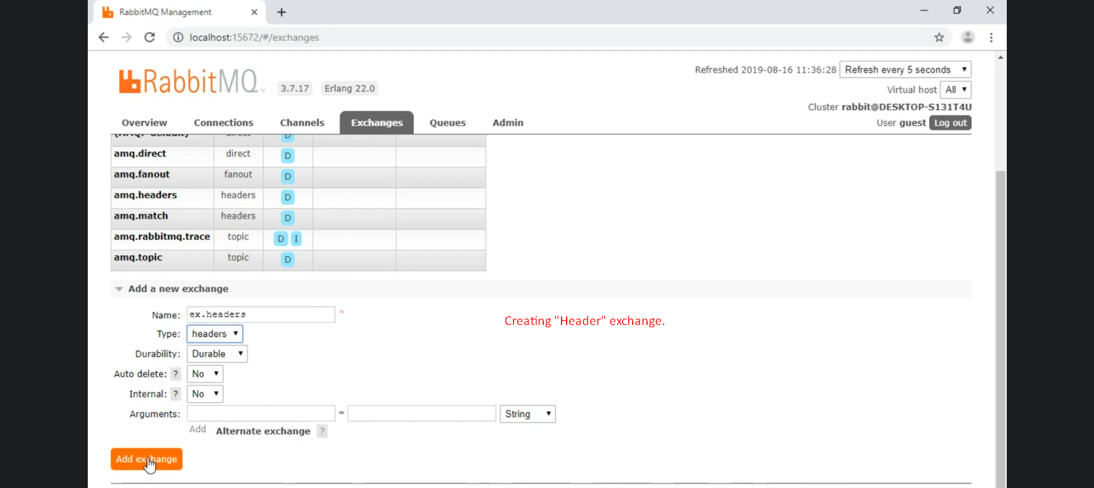
2. Creating Queues.  
   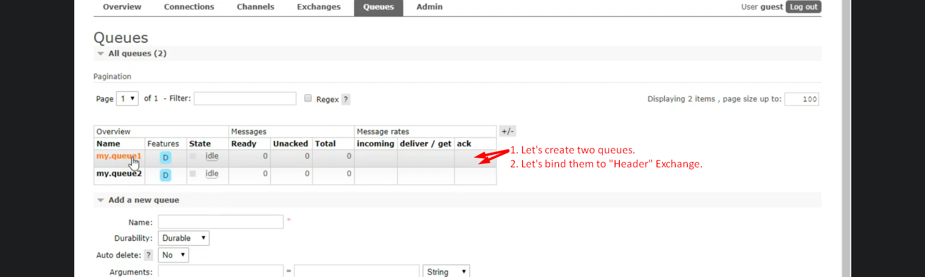
3. Binding Queue with “Header” Exchange.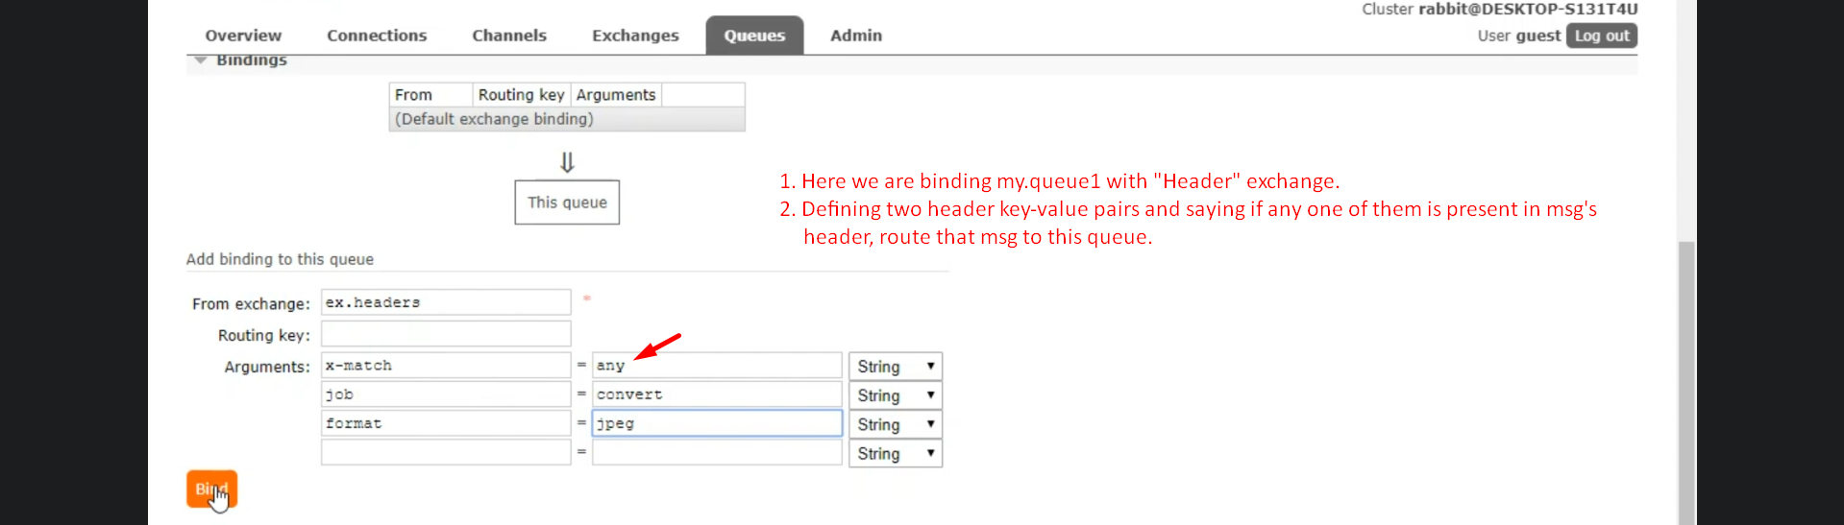  
   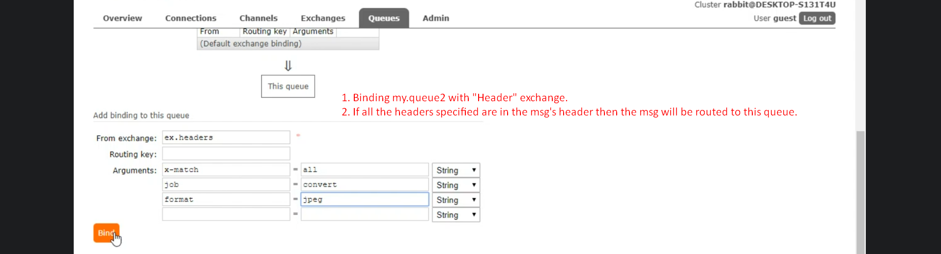
4. 